Identified Patterns

* Tiago Coelho 54622:
  + Pattern 1 – Facade:
    - Illustrating code snippet:

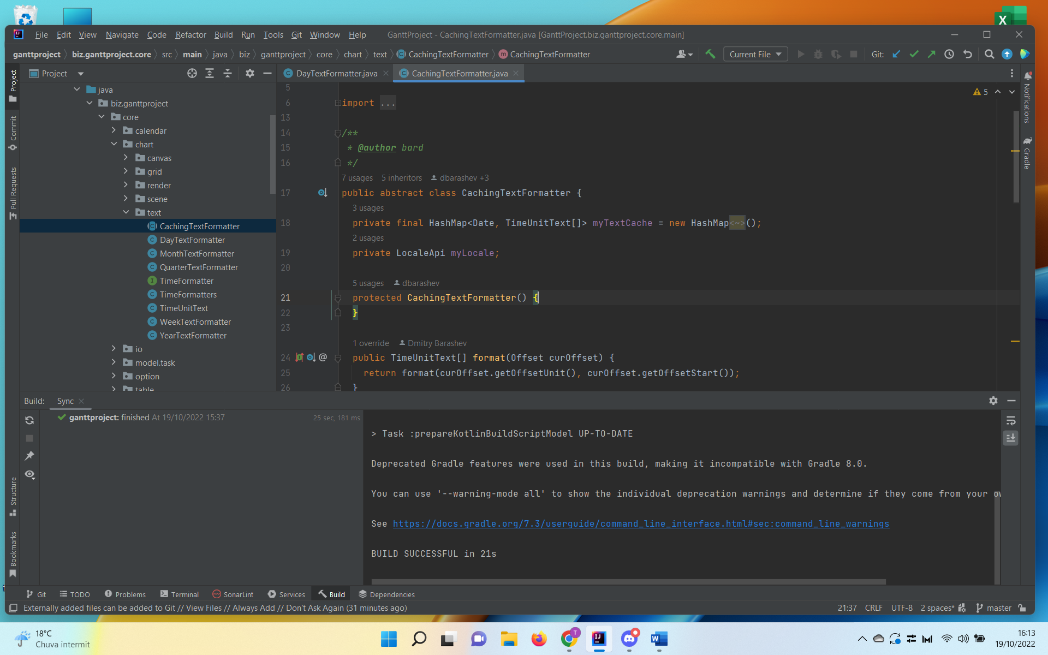

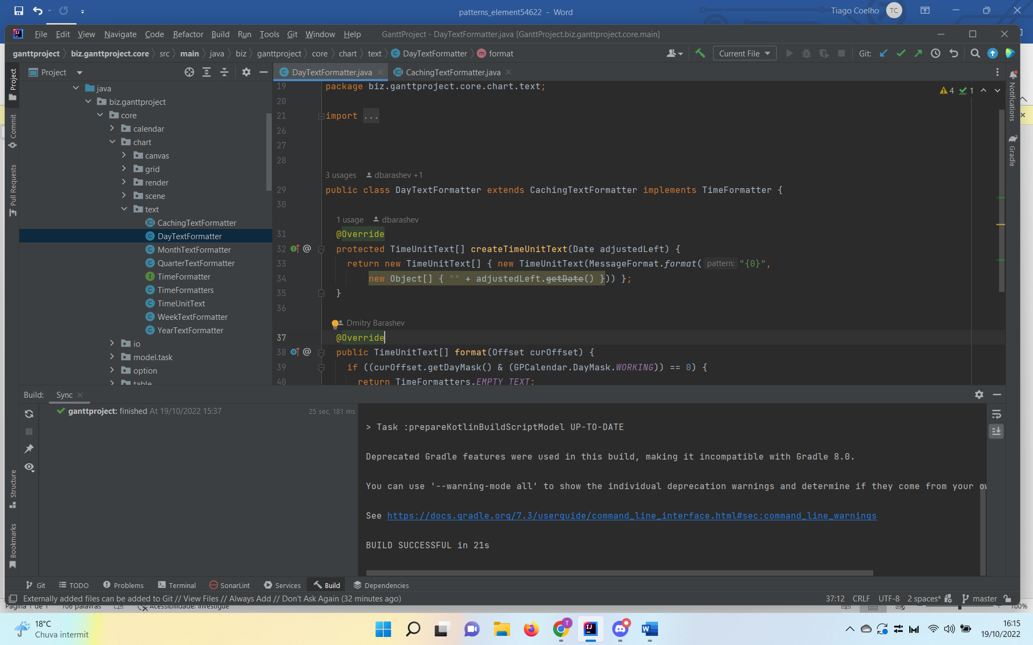

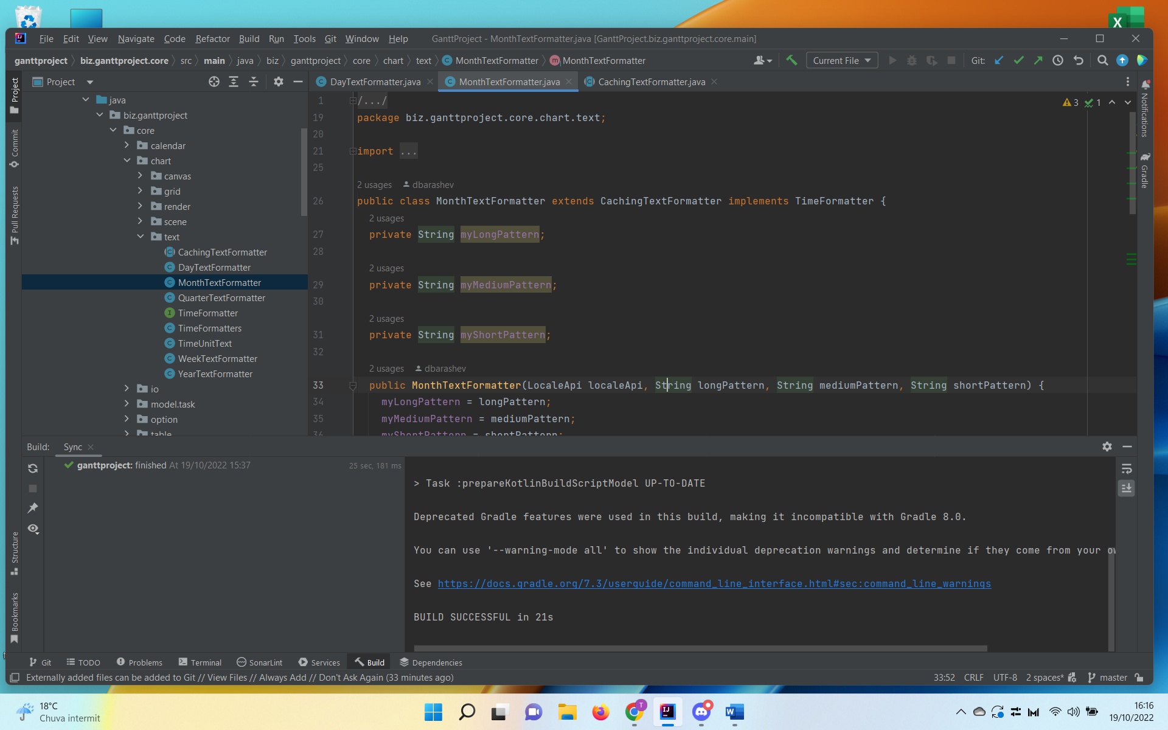

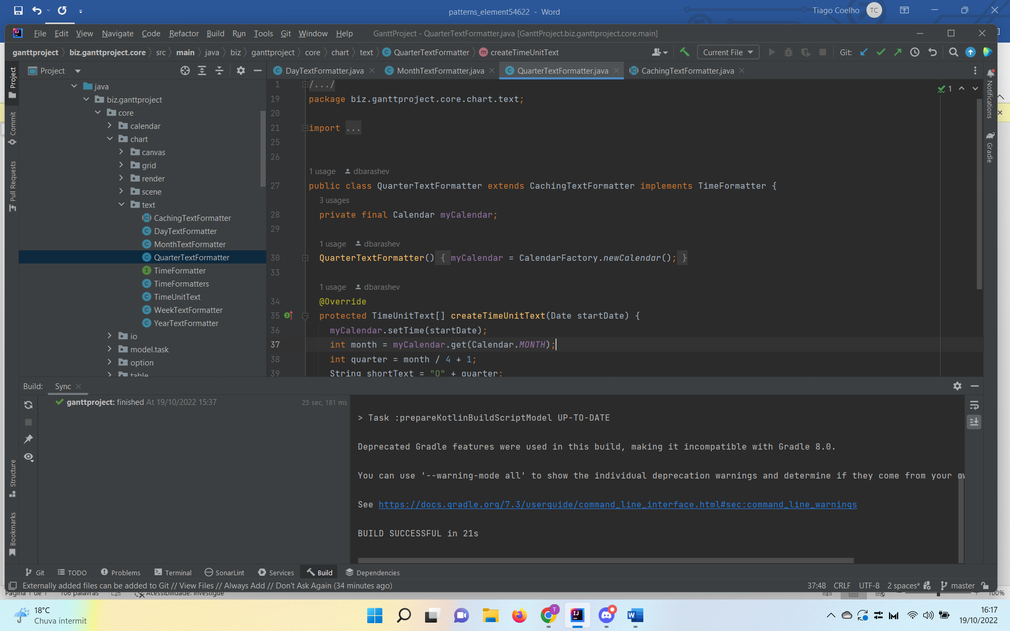

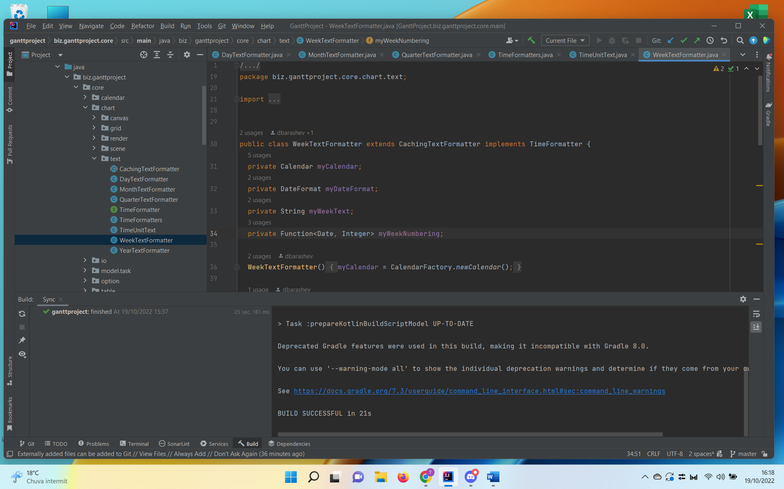

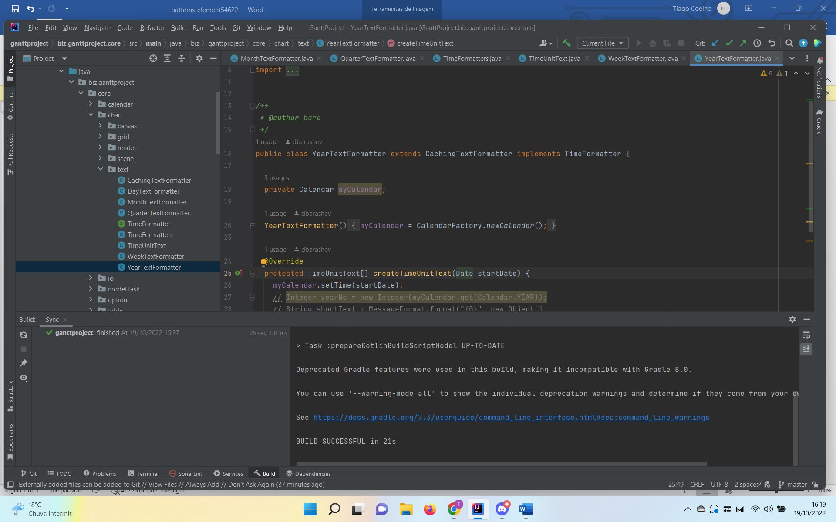

* + - The exact location on the codebase:

biz.ganttproject.core [core] -> src -> main -> java -> bizganttproject -> core -> chart -> text

* + - An explanation of the rationale for identifying this Pattern:

Structuring a system into subsystems helps reduce complexity

* + Pattern 2 – Memento:
    - Illustrating code snippet:

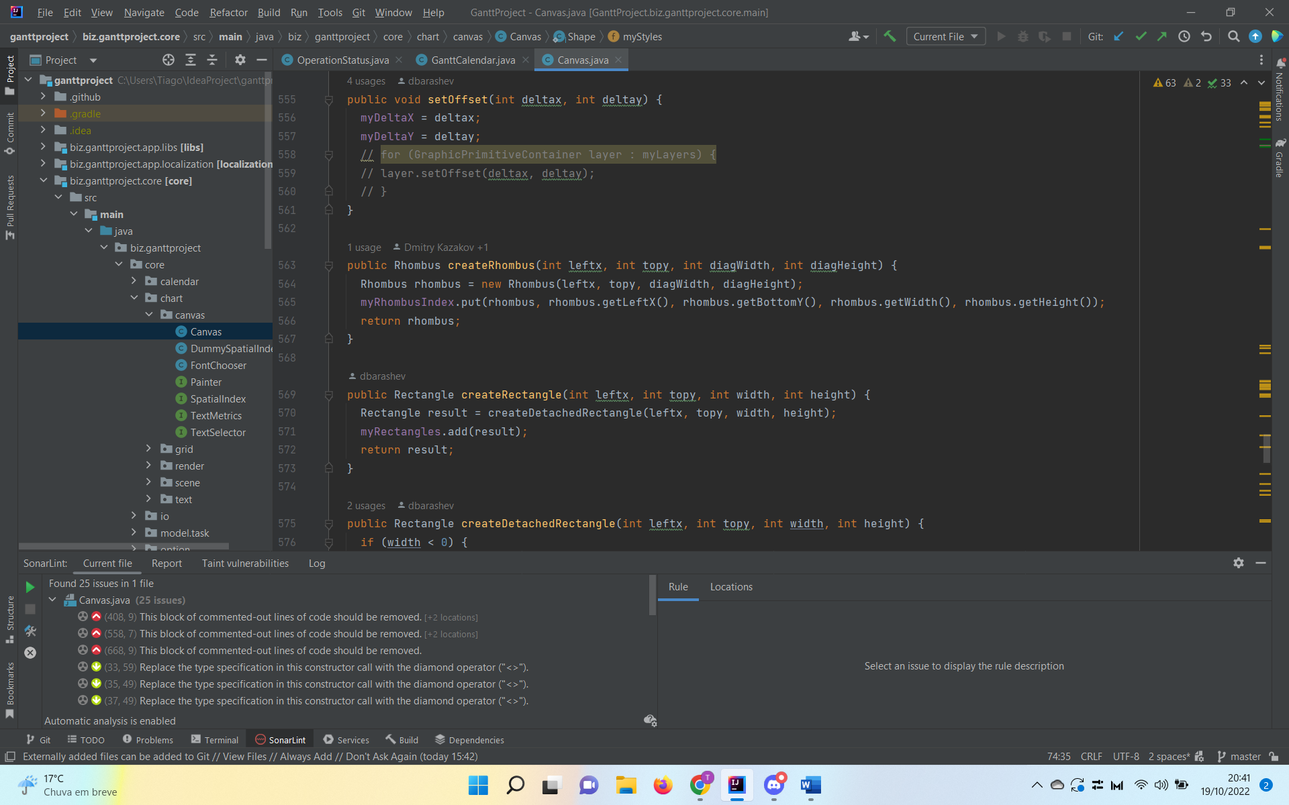

* + - The exact location on the codebase:

biz.ganttproject.core [core] -> src -> main -> java -> bizganttproject -> core -> chart -> chart -> canvas -> Canvas

* + - An explanation of the rationale for identifying this Pattern:

This method needs to return an object.

* + Pattern 3 – Template  
    - Illustrating code snippet:

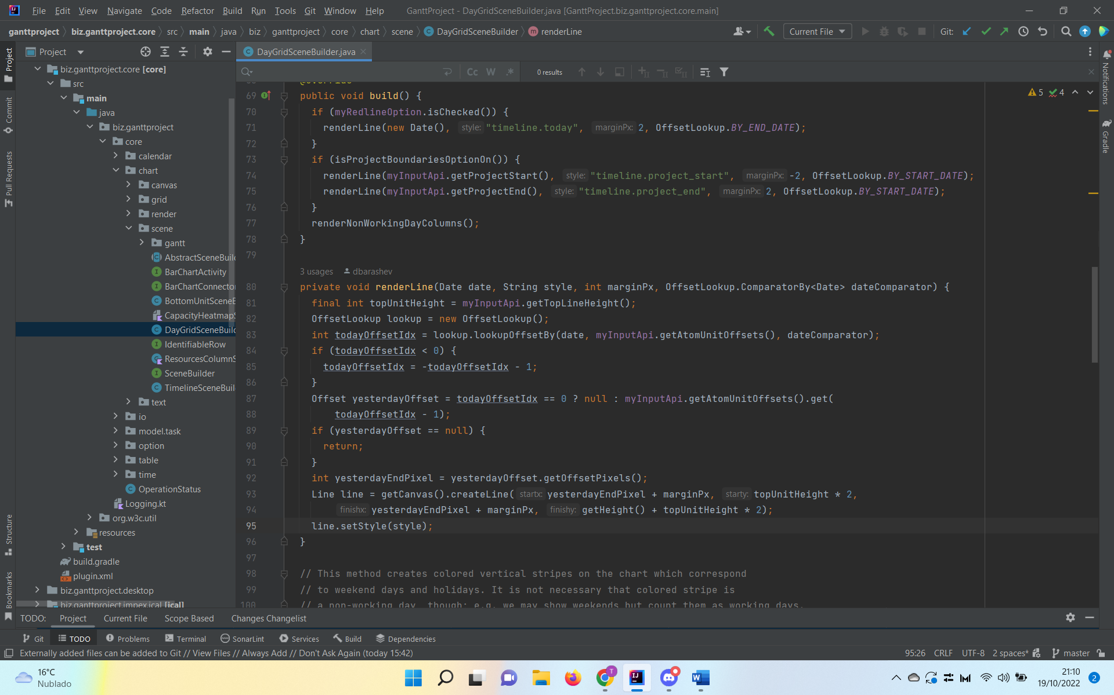

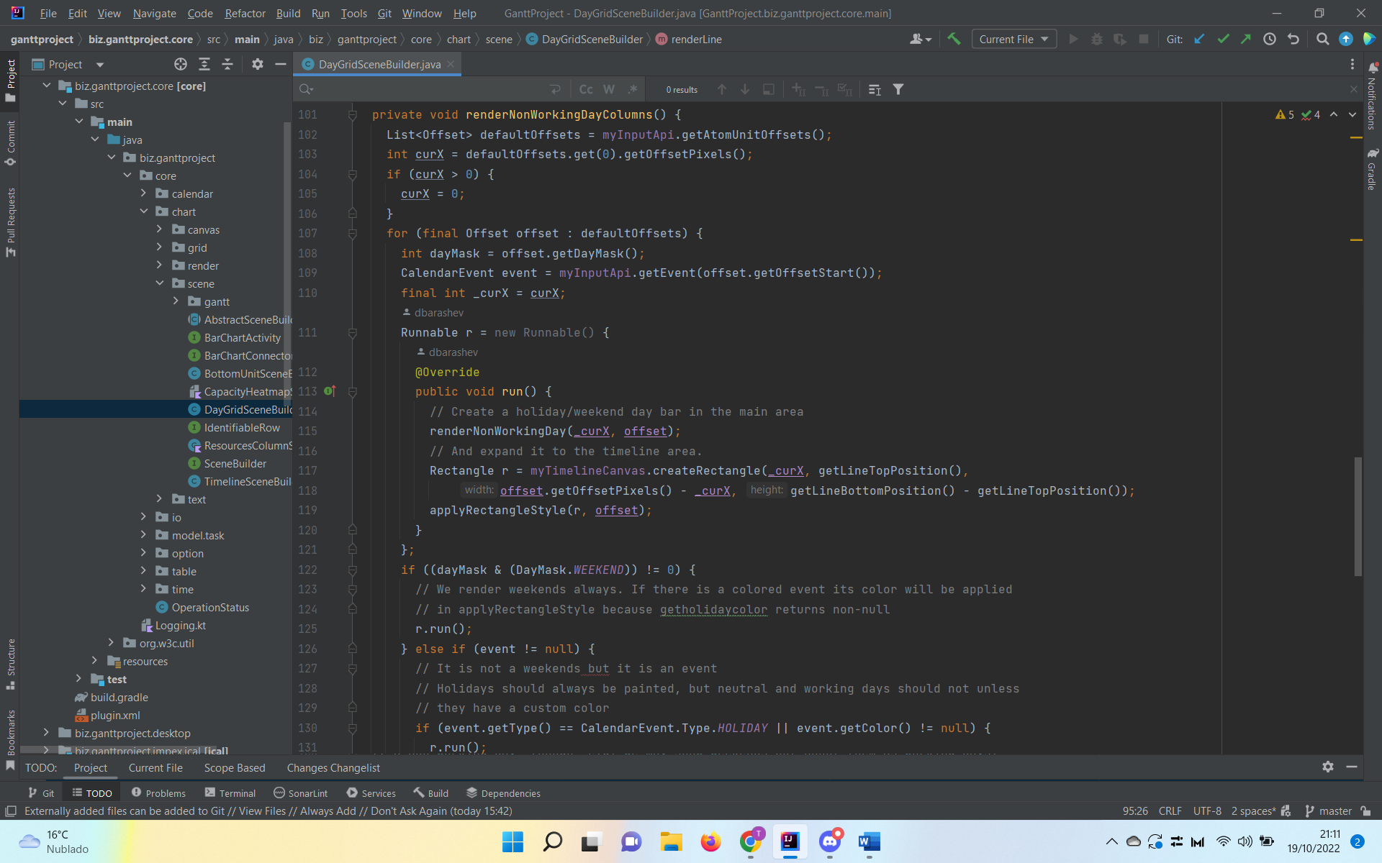

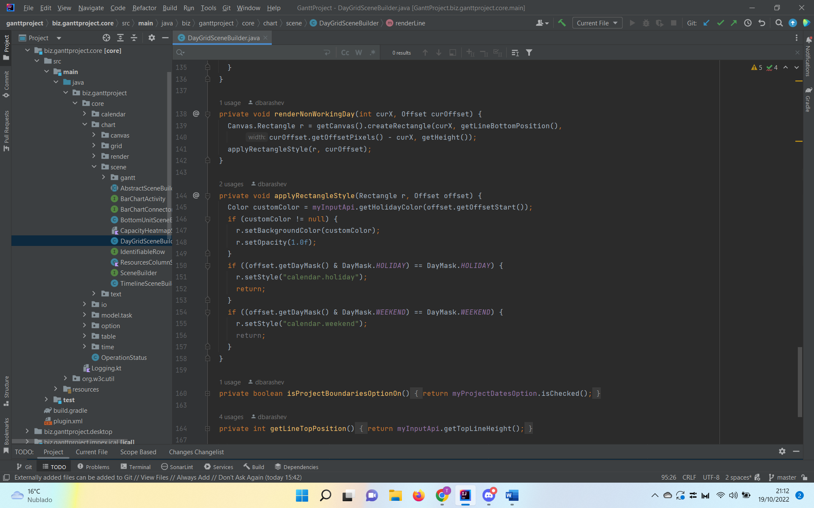

* + - The exact location on the codebase:

biz.ganttproject.core [core] -> src -> main -> java -> bizganttproject -> core -> chart -> scene -> gantt -> DayGridSceneBuilder

* + - An explanation of the rationale for identifying this Pattern:

Defines an algorithm`s steps.